UNITED STATES
SECURITIES AND EXCHANGE COMMISSION
Washington, D.C. 20549
FORM 8-K
CURRENT REPORT
Pursuant to Section 13 or 15(d) of the Securities Exchange Act of 1934
Date of report (Date of earliest event reported): September 9, 2026
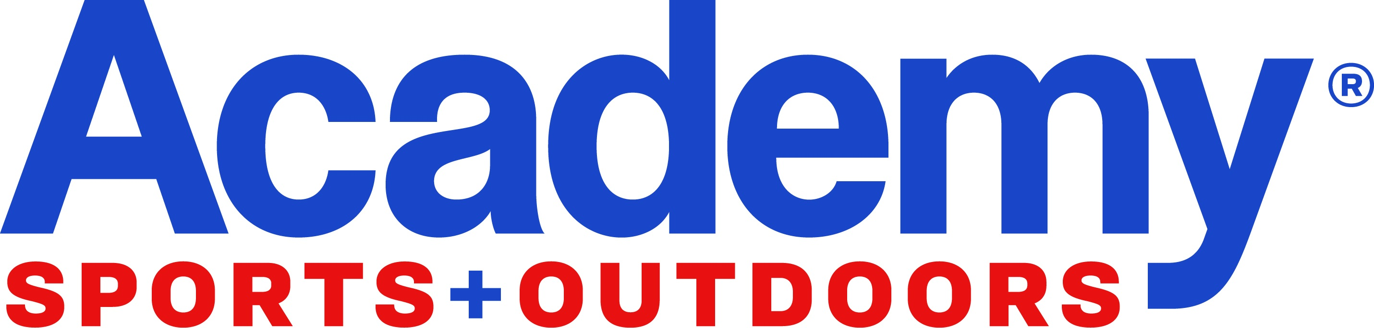
Academy Sports and Outdoors, Inc.
(Exact name of registrant as specified in its charter)
Delaware |  |  |  |  |  | 001-39589 |  |  | 85-1800912
(State or other jurisdiction of |  |  |  |  |  | (Commission |  |  | (I.R.S. Employer
incorporation) |  |  |  |  |  | File No.) |  |  | Identification No.)
 |  |  | 1800 North Mason Road
 |  |  | Katy, Texas 77449
 |  |  | (Address of principal executive offices, including Zip Code)
 |  |  | (281) 646-5200
 |  |  | (Registrant’s telephone number, including area code)
 |  |  | Not Applicable
 |  |  | (Former name or former address, if changed since last report)
Check the appropriate box below if the Form 8-K filing is intended to simultaneously satisfy the filing obligation of the registrant under any of the following provisions:
☐ Written communications pursuant to Rule 425 under the Securities Act (17 CFR 230.425)
☐ Soliciting material pursuant to Rule 14a-12 under the Exchange Act (17 CFR 240.14a-12)
☐ Pre-commencement communications pursuant to Rule 14d-2(b) under the Exchange Act (17 CFR 240.14d-2(b))
☐ Pre-commencement communications pursuant to Rule 13e-4(c) under the Exchange Act (17 CFR 240.13e-4(c))
Securities registered pursuant to Section 12(b) of the Act:
Title of each class |  |  |  |  |  | Trading Symbol(s) |  |  | Name of each exchange on which registered
Common Stock, $0.01 par value per share |  |  |  |  |  | ASO |  |  | The Nasdaq Stock Market LLC
Indicate by check mark whether the registrant is an emerging growth company as defined in Rule 405 of the Securities Act of 1933 (§230.405 of this chapter) or Rule 12b-2 of the Securities Exchange Act of 1934 (§240.12b-2 of this chapter).
Emerging Growth Company ☐
If an emerging growth company, indicate by check mark if the registrant has elected not to use the extended transition period for complying with any new or revised financial accounting standards provided pursuant to Section 13(a) of the Exchange Act. ☐

Item 2.02 Results of Operations and Financial Condition.

On September 9, 2026, Academy Sports and Outdoors, Inc. (the “Company”) issued a press release announcing financial results for the quarter ended August 1, 2026. A copy of the press release is furnished herewith as Exhibit 99.1 and incorporated by reference herein.

The information in this Current Report on Form 8-K, including exhibits, is being furnished to the U.S. Securities and Exchange Commission (the “SEC”) pursuant to Item 2.02 of Form 8-K and shall not be deemed to be “filed” for purposes of Section 18 of the Securities Exchange Act of 1934, as amended (the “Exchange Act”), or otherwise subject to the liabilities of that section, nor shall it be deemed incorporated by reference into any of the Company’s filings with the SEC under the Securities Act of 1933, as amended (the "Securities Act"), or the Exchange Act, except as shall be expressly set forth by specific reference in such a filing.

Item 7.01 Regulation FD Disclosure.

On September 9, 2026, the Company posted the Second Quarter 2026 Earnings Presentation to its website at investors.academy.com. A copy of the presentation is attached hereto as Exhibit 99.2.

The information contained under this Item 7.01, including Exhibit 99.2, is being furnished and shall not be deemed to be “filed” for purposes of Section 18 of the Exchange Act, or otherwise subject to the liabilities of that Section, nor shall it be deemed incorporated by reference in any filing under the Securities Act or the Exchange Act, except as expressly set forth by specific reference in such filing.

Item 9.01 Financial Statements and Exhibits.

(d) Exhibits.

See the Exhibit Index immediately preceding the signature page hereto, which is incorporated herein by reference.

Exhibit No. |  |  |  |  |  | Description of Exhibit
99.1 |  |  |  |  |  | Academy Sports and Outdoors, Inc. Press Release, dated September 9, 2026.
99.2 |  |  |  |  |  | Second Quarter 2026 Earnings Presentation, dated September 9, 2026.
104 |  |  |  |  |  | Cover Page Interactive Data File (embedded within the Inline XBRL document).

Signatures

Pursuant to the requirements of the Securities Exchange Act of 1934, the registrant has duly caused this report to be signed on its behalf by the undersigned hereunto duly authorized.

ACADEMY SPORTS AND OUTDOORS, INC.

Date: September 9, 2026 |  |  |  |  |  | By: |  |  | /s/ |  |  | Brandy Treadway
 |  |  |  |  |  | Name: |  |  | Brandy Treadway
 |  |  |  |  |  | Title: |  |  | Executive Vice President, Chief Legal Officer and Corporate Secretary

Exhibit 99.1



Academy Sports + Outdoors Reports Second Quarter Fiscal 2026 Results

Second Quarter Sales Growth of 3.0%; Comparable Sales of (0.4)%

eCommerce Sales Increase of 12.8%

New Stores Comp Positive Mid Single Digits

Second Quarter Diluted GAAP EPS of $2.17; up 17.3%; Adjusted EPS of $2.31; up 19.1%
(Net Tariff Refund Impact to EPS of $0.06, including reinvestments)

Opened Three New Stores Across Pennsylvania and Tennessee

Company Affirms Sales and Raises EPS Guidance

KATY, TEXAS (Globe Newswire — September 9, 2026) – Academy Sports and Outdoors, Inc. (Nasdaq: ASO) (“Academy” or the “Company” ) today announced its financial results for the second quarter ended August 1, 2026.

“We delivered another quarter of profitable growth, with net sales increasing 3.0%. While consumer spending remains pressured, particularly among lower-income households, our team has continued to execute at a high level by focusing on the key events and categories that matter most to our customers," said Steve Lawrence, Chief Executive Officer. "We are reinvesting tariff-related benefits into value, expanding compelling new brands and categories, and accelerating initiatives across stores, omni-channel and loyalty. These actions are helping us gain market share, strengthen customer engagement and reinforce our confidence in achieving our fiscal 2026 sales and earnings objectives."

Second Quarter Operating Results  ($ in millions, except per share data) |  |  |  |  |  | Thirteen Weeks Ended |  |  |  |  |  | Change
 |  |  |  |  |  | August 1, 2026 |  |  | August 2, 2025 |  |  | %
Net sales |  |  |  |  |  | $ | 1,647.3 |  | $ | 1,599.8 |  | 3.0%
Comparable sales |  |  |  |  |  | (0.4) |  | % | 0.2 |  | %
Income before income tax |  |  |  |  |  | $ | 178.4 |  | $ | 164.8 |  | 8.3%
Net income |  |  |  |  |  | $ | 137.9 |  | $ | 125.4 |  | 10.0%
Adjusted net income (1) |  |  |  |  |  | $ | 146.5 |  | $ | 131.3 |  | 11.6%
Earnings per common share, diluted |  |  |  |  |  | $ | 2.17 |  | $ | 1.85 |  | 17.3%
Adjusted earnings per common share, diluted(1) |  |  |  |  |  | $ | 2.31 |  | $ | 1.94 |  | 19.1%
(1) Adjusted net income and adjusted earnings per common share (EPS), diluted are non-GAAP measures. See "Non-GAAP Measures" and "Reconciliations of GAAP to Non-GAAP Financial Measures" below for reconciliations of non-GAAP financial measures to their most directly comparable GAAP financial measures.

1
Year-to-Date Operating Results ($ in millions, except per share data) |  |  |  |  |  | Twenty-Six Weeks Ended |  |  |  |  |  | Change
 |  |  |  |  |  | August 1, 2026 |  |  | August 2, 2025 |  |  | %
Net sales |  |  |  |  |  | $ | 3,089.3 |  | $ | 2,951.2 |  | 4.7%
Comparable sales |  |  |  |  |  | 1.1 |  | % | (1.7) |  | %
Income before income tax |  |  |  |  |  | $ | 247.3 |  | $ | 227.9 |  | 8.5%
Net Income |  |  |  |  |  | $ | 190.6 |  | $ | 171.5 |  | 11.1%
Adjusted net income (1) |  |  |  |  |  | $ | 207.7 |  | $ | 182.9 |  | 13.6%
Earnings per common share, diluted |  |  |  |  |  | $ | 2.94 |  | $ | 2.52 |  | 16.7%
Adjusted earnings per common share, diluted (1) |  |  |  |  |  | $ | 3.20 |  | $ | 2.69 |  | 19.0%
(1) Adjusted net income and Adjusted earnings per common share, diluted, are non-GAAP measures. See "Non-GAAP Measures" and "Reconciliations of GAAP to Non-GAAP Financial Measures" below for reconciliations of non-GAAP financial measures to their most directly comparable GAAP financial measures.

 |  |  |  |  |  | Twenty-Six Weeks Ended |  |  |  |  |  | Change
Balance Sheet ($ in millions) |  |  |  |  |  | August 1, 2026 |  |  | August 2, 2025 |  |  | %
Cash and cash equivalents |  |  |  |  |  | $ | 298.2 |  | $ | 300.9 |  | (0.9)%
Merchandise inventories, net(1) |  |  |  |  |  | $ | 1,657.4 |  | $ | 1,587.6 |  | 4.4%
Long-term debt, net |  |  |  |  |  | $ | 494.2 |  | $ | 481.7 |  | 2.6%
(1) As of August 1, 2026 inventory per store was down 5.6% in units and down 2.3% in dollars.

 |  |  |  |  |  | Twenty-Six Weeks Ended |  |  |  |  |  | Change
Capital Allocation ($ in millions) |  |  |  |  |  | August 1, 2026 |  |  | August 2, 2025 |  |  | %
Share repurchases (1) |  |  |  |  |  | $ | 182.1 |  | $ | 99.9 |  | 82.3 |  | %
Dividends paid |  |  |  |  |  | $ | 19.0 |  | $ | 17.4 |  | 9.2 |  | %
(1) Includes excise tax fees of $1.6 million for the twenty-six weeks ended August 1, 2026 and $0.9 million for the twenty-six weeks ended August 2, 2025.

Subsequent to the end of the second quarter, Academy announced that its Board of Directors on September 2, 2026 declared a quarterly cash dividend with respect to the quarter ended August 1, 2026, of $0.15 per share of common stock. The dividend is payable on October 14, 2026, to stockholders of record as of the close of business on September 16, 2026.

New Store Openings
Academy opened three new stores during the second quarter, bringing its total to 327 locations. The Company plans to open eleven stores during the third quarter, with the remaining locations to be opened in the fourth quarter of fiscal 2026.

Academy Store Footprint Update

Time Frame |  |  | Total stores open at beginning of the period |  |  | Number of stores opened during the period |  |  | Number of stores closed during the period |  |  | Total stores open at end of period
2nd Quarter 2025 |  |  | 303 |  |  | 3 |  |  | — |  |  | 306
FY 2025 |  |  | 298 |  |  | 24 |  |  | — |  |  | 322
2nd Quarter 2026 |  |  | 324 |  |  | 3 |  |  | — |  |  | 327

Time Frame |  |  | Total gross square feet open at beginning of the period(1) |  |  | Gross square feet for stores opened during the period(1) |  |  | Gross square feet for stores closed during the period |  |  | Total gross square feet at the end of the period(1)
2nd Quarter 2025 |  |  | 20,879 |  |  | 191 |  |  |  |  |  | 21,070
FY 2025 |  |  | 20,604 |  |  | 1,321 |  |  | — |  |  | 21,925
2nd Quarter 2026 |  |  | 22,037 |  |  | 154 |  |  | — |  |  | 22,191
(1) Figures in thousands

2
2026 Outlook
“Our second quarter results demonstrate the strength of the business and the discipline of our operating model. We delivered double digit EPS growth, produced strong free cash flow and continued returning capital to shareholders through both share repurchases and dividends. Importantly, we accomplished this while investing in strategic growth initiatives designed to support sustainable long-term growth,” said Carl Ford, Executive Vice President and Chief Financial Officer. “As we enter the second half of the year, our balance sheet remains strong, our growth drivers are performing well and we are well positioned to deliver within our fiscal 2026 outlook."

Academy is providing the following updated guidance for fiscal 2026 (i.e., year ending January 30, 2027), as compared to the guidance given on June 9, 2026. This guidance takes into account various factors, both internal and external, such as the expected benefits of the Company's growth initiatives, current consumer demand, the competitive environment, and potential impacts from inflation and other economic risks; actual results may differ materially.

 |  |  | Fiscal 2026 Guidance June 9 |  |  |  |  |  | Updated Fiscal 2026 Guidance |  |  |  |  |  |  |  |  |  |  |  | change (at midpoint)
(in millions, except per share amounts) |  |  | Low end |  |  | High end |  |  | Low end |  |  | High end |  |  | 2025 Actuals |  |  |  |  |  | vs. 2025
Net sales |  |  | $6,230 |  |  | $6,355 |  |  | $6,230 |  |  | $6,355 |  |  | $6,053 |  |  |  |  |  | 4.0 |  | %
Sales Growth |  |  | 3.0 |  | % | 5.0 |  | % | 3.0 |  | % | 5.0 |  | % | 2.0 |  | % |  |  |  | 100.0 |  | %
Comparable sales (1) |  |  | — |  | % | 2.0 |  | % | — |  | % | 2.0 |  | % | (1.5) |  | % |  |  |  | 166.7 |  | %
Gross margin rate |  |  | 34.5 |  | % | 35.0 |  | % | 35.5 |  | % | 36.0 |  | % | 34.8 |  | % |  |  |  | 3.0 |  | %
GAAP net income |  |  | $390 |  |  | $415 |  |  | $390 |  |  | $415 |  |  | $377 |  |  |  |  |  | 6.8 |  | %
Adjusted net income (2) |  |  | $420 |  |  | $445 |  |  | $420 |  |  | $445 |  |  | $393 |  |  |  |  |  | 10.1 |  | %
GAAP earnings per common share, diluted |  |  | $5.95 |  |  | $6.35 |  |  | $6.05 |  |  | $6.45 |  |  | $5.54 |  |  |  |  |  | 12.8 |  | %
Adjusted earnings per common share, diluted (2) |  |  | $6.40 |  |  | $6.80 |  |  | $6.50 |  |  | $6.90 |  |  | $5.78 |  |  |  |  |  | 15.9 |  | %
Diluted weighted average common shares |  |  | 66 |  |  | 66 |  |  | 64.5 |  |  | 64.5 |  |  | ~68 |  |  |  |  |  | (5.2) |  | %
Capital Expenditures |  |  | $200 |  |  | $240 |  |  | $200 |  |  | $240 |  |  | $213 |  |  |  |  |  | 3.3 |  | %
Adjusted free cash flow (2), (3) |  |  | $250 |  |  | $300 |  |  | $300 |  |  | $350 |  |  | $263 |  |  |  |  |  | 23.6 |  | %

The earnings per share estimates do not include any potential future share repurchases and assume a tax rate of approximately 22.0%.

(1) Comparable sales include stores open after thirteen full fiscal months, all e-commerce sales, and credit card revenue.

(2) Adjusted net income, adjusted earnings per common share (EPS), diluted, and adjusted free cash flow are non-GAAP measures. See "Non-GAAP Measures" and "Reconciliations of GAAP to Non-GAAP Financial Measures" below for reconciliations of non-GAAP financial measures to their most directly comparable GAAP financial measures.

(3) We have not reconciled guidance for adjusted free cash flow to the most comparable GAAP measure because it is not possible to do so without unreasonable efforts given the uncertainty and potential variability of reconciling items, which are dependent on future events and often outside of management's control and could be significant; therefore, we are unable to provide an estimate of the most closely comparable GAAP measure at this time.

3
Conference Call Info
Academy will host a conference call today at 10:00 a.m. Eastern Time to discuss its financial results and related matters. The call will be webcast at investors.academy.com. The following information is provided for those who would like to participate in the conference call:

U.S. callers 1-877-407-3982
International callers 1-201-493-6780
Passcode 13762096

A replay of the conference call will be available for approximately 30 days on the Company's website.

About Academy Sports + Outdoors
Academy is a leading full-line sporting goods and outdoor recreation retailer in the United States. Originally founded in 1938 as a family business in Texas, Academy has grown to more than 300 stores across 21 states and counting. Academy's mission is to provide "Fun for All" and Academy fulfills this mission with a localized merchandising strategy and value proposition that strongly connects with a broad range of consumers. Academy's product assortment focuses on key categories of outdoor, apparel, sports & recreation and footwear through both leading national brands and a portfolio of private label brands. For more information, visit www.academy.com.

Non-GAAP Measures
Adjusted EBIT, Adjusted Net Income, Adjusted Earnings per Common Share, and Adjusted Free Cash Flow have been presented in this press release as supplemental measures of financial performance that are not required by, or presented in accordance with, generally accepted accounting principles (“GAAP”). The Company believes that the presentation of these non-GAAP measures is useful to investors as they provide additional information on comparisons between periods by excluding certain items that affect overall comparability. The Company uses these non-GAAP financial measures for business planning purposes, to consider underlying trends of its business, and in measuring its performance relative to others in the market, and believes presenting these measures also provides information to investors and others for understanding and evaluating trends in the Company’s operating results or measuring performance in the same manner as the Company’s management. Non-GAAP financial measures should be considered in addition to, and not as an alternative for, the Company’s reported results prepared in accordance with GAAP. The calculation of these non-GAAP financial measures may differ from similar measures reported by other companies and may not be comparable to other similarly titled measures. For additional information on these non-GAAP financial measures, please see our Annual Report for the fiscal year ended January 31, 2026 (the "Annual Report"), filed on March 17, 2026 and our Quarterly Report for the thirteen weeks ended August 1, 2026 to be filed on September 9, 2026 ("the Quarterly Report"), which may be updated from time to time in our periodic filings with the Securities and Exchange Commission (the "SEC"), which are accessible on the SEC's website at www.sec.gov.

See “Reconciliations of GAAP to Non-GAAP Financial Measures” below for reconciliations of non-GAAP financial measures presented in this press release to their most directly comparable GAAP financial measures.

Forward-Looking Statements

This press release contains forward-looking statements within the meaning of Section 27A of the Securities Act of 1933, as amended, and Section 21E of the Securities Exchange Act of 1934, as amended. These forward-looking statements are based on Academy’s current expectations and are not guarantees of future performance. Forward-looking statements may incorporate words such as “believe,” “expect,", "anticipate," “forward,” “ahead,” “opportunities,” “plans,” “priorities,” “goals,” “future,” “short/long term,” “will,” “should,” or the negative version of these words or other comparable words. The forward-looking statements in this press release include, among other things, statements regarding the Company’s fiscal 2026 outlook under the caption "2026 Outlook," the Company's strategic plans and financial objectives, including the implementation of such plans, the growth of the Company's business and operations, including the opening of new stores and the expansion into new markets, the Company's payment of dividends, including the timing and the amount thereof, share repurchases by the Company, and the Company's expectations regarding its future performance and future financial condition are subject to various risks, uncertainties, assumptions, or changes in circumstances that are all difficult to predict or quantify. Actual results may differ materially from these expectations due to changes in global, regional, or local economic, business, competitive, market, regulatory, environmental, and other factors that could affect overall consumer spending or our industry, including the possible effects of ongoing macroeconomic challenges, inflation and higher interest rates, trade policy changes or additional tariffs, geopolitical tensions, or changes to the financial health of our customers, many of which are beyond Academy's control. These and other important factors that could cause actual results to differ materially from those in the forward-looking statements are set forth in Academy's filings with the SEC, including the Annual Report, under the caption "Part 1A. Risk Factors," as may be updated from time to time in our periodic filings with the SEC. Any forward-looking statement in this press release speaks only as of the date of this release. Academy undertakes no obligation to publicly update or review any forward-looking statement, whether as a result of new information, future developments or otherwise, except as may be required by any applicable securities laws.

4
Investor Contact |  |  |  |  |  | Media Contact
Dan Aldridge |  |  |  |  |  | Meredith Klein
VP, Investor Relations |  |  |  |  |  | VP, Communications
832-739-4102 |  |  |  |  |  | 346-823-6615
dan.aldridge@academy.com |  |  |  |  |  | meredith.klein@academy.com

5

ACADEMY SPORTS AND OUTDOORS, INC.
CONSOLIDATED STATEMENTS OF INCOME
(Unaudited)
(Amounts in thousands, except per share data)

 |  |  | Thirteen Weeks Ended
 |  |  | August 1, 2026 |  |  |  |  |  | Percentage of Sales (1) |  |  |  |  |  | August 2, 2025 |  |  |  |  |  | Percentage of Sales (1)
Net sales |  |  | $ | 1,647,285 |  |  |  |  | 100.0 |  | % |  |  |  | $ | 1,599,838 |  |  |  |  | 100.0 |  | %
Cost of goods sold |  |  | 981,383 |  |  |  |  |  | 59.6 |  | % |  |  |  | 1,023,105 |  |  |  |  |  | 64.0 |  | %
Gross margin |  |  | 665,902 |  |  |  |  |  | 40.4 |  | % |  |  |  | 576,733 |  |  |  |  |  | 36.0 |  | %
Selling, general and administrative expenses |  |  | 419,539 |  |  |  |  |  | 25.5 |  | % |  |  |  | 404,352 |  |  |  |  |  | 25.3 |  | %
Operating income |  |  | 246,363 |  |  |  |  |  | 15.0 |  | % |  |  |  | 172,381 |  |  |  |  |  | 10.8 |  | %
Interest expense, net |  |  | 8,056 |  |  |  |  |  | 0.5 |  | % |  |  |  | 9,028 |  |  |  |  |  | 0.6 |  | %
Loss on early retirement of debt |  |  | 1,902 |  |  |  |  |  | 0.1 |  | % |  |  |  | — |  |  |  |  |  | — |  | %
Other expense (income), net |  |  | 58,006 |  |  |  |  |  | 3.5 |  | % |  |  |  | (1,480) |  |  |  |  |  | (0.1) |  | %
Income before income taxes |  |  | 178,399 |  |  |  |  |  | 10.8 |  | % |  |  |  | 164,833 |  |  |  |  |  | 10.3 |  | %
Income tax expense |  |  | 40,502 |  |  |  |  |  | 2.5 |  | % |  |  |  | 39,399 |  |  |  |  |  | 2.5 |  | %
Net income |  |  | $ | 137,897 |  |  |  |  | 8.4 |  | % |  |  |  | $ | 125,434 |  |  |  |  | 7.8 |  | %
Earnings Per Common Share:
Basic |  |  | $ | 2.21 |  |  |  |  |  |  |  |  |  |  | $ | 1.89
Diluted |  |  | $ | 2.17 |  |  |  |  |  |  |  |  |  |  | $ | 1.85
Weighted Average Common Shares Outstanding:
Basic |  |  | 62,292 |  |  |  |  |  |  |  |  |  |  |  | 66,539
Diluted |  |  | 63,551 |  |  |  |  |  |  |  |  |  |  |  | 67,689
(1) Column may not add due to rounding

6

ACADEMY SPORTS AND OUTDOORS, INC.
CONSOLIDATED STATEMENTS OF INCOME
(Unaudited)
(Amounts in thousands, except per share data)

 |  |  | Twenty-Six Weeks Ended
 |  |  | August 1, 2026 |  |  |  |  |  | Percentage of Sales (1) |  |  |  |  |  | August 2, 2025 |  |  |  |  |  | Percentage of Sales (1)
Net sales |  |  | $ | 3,089,288 |  |  |  |  | 100.0 |  | % |  |  |  | $ | 2,951,247 |  |  |  |  | 100.0 |  | %
Cost of goods sold |  |  | 1,944,038 |  |  |  |  |  | 62.9 |  | % |  |  |  | 1,915,645 |  |  |  |  |  | 64.9 |  | %
Gross margin |  |  | 1,145,250 |  |  |  |  |  | 37.1 |  | % |  |  |  | 1,035,602 |  |  |  |  |  | 35.1 |  | %
Selling, general and administrative expenses |  |  | 824,232 |  |  |  |  |  | 26.7 |  | % |  |  |  | 793,956 |  |  |  |  |  | 26.9 |  | %
Operating income |  |  | 321,018 |  |  |  |  |  | 10.4 |  | % |  |  |  | 241,646 |  |  |  |  |  | 8.2 |  | %
Interest expense, net |  |  | 17,043 |  |  |  |  |  | 0.6 |  | % |  |  |  | 18,072 |  |  |  |  |  | 0.6 |  | %
Loss on early retirement of debt |  |  | 1,902 |  |  |  |  |  | 0.1 |  | % |  |  |  | — |  |  |  |  |  | — |  | %
Other expense (income), net |  |  | 54,785 |  |  |  |  |  | 1.8 |  | % |  |  |  | (4,287) |  |  |  |  |  | (0.1) |  | %
Income before income taxes |  |  | 247,288 |  |  |  |  |  | 8.0 |  | % |  |  |  | 227,861 |  |  |  |  |  | 7.7 |  | %
Income tax expense |  |  | 56,688 |  |  |  |  |  | 1.8 |  | % |  |  |  | 56,343 |  |  |  |  |  | 1.9 |  | %
Net income |  |  | $ | 190,600 |  |  |  |  | 6.2 |  | % |  |  |  | $ | 171,518 |  |  |  |  | 5.8 |  | %
Earnings Per Common Share:
Basic |  |  | $ | 3.01 |  |  |  |  |  |  |  |  |  |  | $ | 2.57
Diluted |  |  | $ | 2.94 |  |  |  |  |  |  |  |  |  |  | $ | 2.52
Weighted Average Common Shares Outstanding:
Basic |  |  | 63,362 |  |  |  |  |  |  |  |  |  |  |  | 66,831
Diluted |  |  | 64,892 |  |  |  |  |  |  |  |  |  |  |  | 68,043
(1) Column may not add due to rounding

7
ACADEMY SPORTS AND OUTDOORS, INC.
CONSOLIDATED BALANCE SHEETS
(Unaudited)
(Amounts in thousands, except per share data)

 |  |  |  |  |  | August 1, 2026 |  |  |  |  |  | January 31, 2026 |  |  |  |  |  | August 2, 2025
ASSETS
CURRENT ASSETS:
Cash and cash equivalents |  |  |  |  |  | $ | 298,213 |  |  |  |  | $ | 330,320 |  |  |  |  | $ | 300,860
Accounts receivable - less allowance for doubtful accounts of $1,592, $1,792 and $1,874, respectively |  |  |  |  |  | 22,955 |  |  |  |  |  | 34,755 |  |  |  |  |  | 19,181
Merchandise inventories, net |  |  |  |  |  | 1,657,442 |  |  |  |  |  | 1,503,756 |  |  |  |  |  | 1,587,624
Prepaid expenses and other current assets |  |  |  |  |  | 89,897 |  |  |  |  |  | 82,457 |  |  |  |  |  | 78,257
Assets held for sale |  |  |  |  |  | 2,957 |  |  |  |  |  | 2,957 |  |  |  |  |  | —
Total current assets |  |  |  |  |  | 2,071,464 |  |  |  |  |  | 1,954,245 |  |  |  |  |  | 1,985,922
PROPERTY AND EQUIPMENT, NET |  |  |  |  |  | 631,834 |  |  |  |  |  | 584,103 |  |  |  |  |  | 584,045
RIGHT-OF-USE ASSETS |  |  |  |  |  | 1,292,724 |  |  |  |  |  | 1,234,246 |  |  |  |  |  | 1,206,207
TRADE NAME |  |  |  |  |  | 579,972 |  |  |  |  |  | 579,766 |  |  |  |  |  | 579,330
GOODWILL |  |  |  |  |  | 861,920 |  |  |  |  |  | 861,920 |  |  |  |  |  | 861,920
OTHER NONCURRENT ASSETS |  |  |  |  |  | 70,234 |  |  |  |  |  | 62,756 |  |  |  |  |  | 58,559
Total assets |  |  |  |  |  | $ | 5,508,148 |  |  |  |  | $ | 5,277,036 |  |  |  |  | $ | 5,275,983
LIABILITIES AND STOCKHOLDERS' EQUITY
CURRENT LIABILITIES:
Accounts payable |  |  |  |  |  | $ | 751,560 |  |  |  |  | $ | 637,854 |  |  |  |  | $ | 803,309
Accrued expenses and other current liabilities |  |  |  |  |  | 302,513 |  |  |  |  |  | 243,908 |  |  |  |  |  | 266,021
Current lease liabilities |  |  |  |  |  | 134,390 |  |  |  |  |  | 147,491 |  |  |  |  |  | 139,678
Current maturities of long-term debt |  |  |  |  |  | — |  |  |  |  |  | 3,000 |  |  |  |  |  | 3,000
Total current liabilities |  |  |  |  |  | 1,188,463 |  |  |  |  |  | 1,032,253 |  |  |  |  |  | 1,212,008
LONG-TERM DEBT, NET |  |  |  |  |  | 494,158 |  |  |  |  |  | 480,793 |  |  |  |  |  | 481,738
LONG-TERM LEASE LIABILITIES |  |  |  |  |  | 1,340,337 |  |  |  |  |  | 1,261,167 |  |  |  |  |  | 1,217,217
DEFERRED TAX LIABILITIES, NET |  |  |  |  |  | 285,589 |  |  |  |  |  | 300,654 |  |  |  |  |  | 270,502
OTHER LONG-TERM LIABILITIES |  |  |  |  |  | 21,168 |  |  |  |  |  | 30,792 |  |  |  |  |  | 19,368
Total liabilities |  |  |  |  |  | 3,329,715 |  |  |  |  |  | 3,105,659 |  |  |  |  |  | 3,200,833
COMMITMENTS AND CONTINGENCIES
STOCKHOLDERS' EQUITY :
Preferred stock, $0.01 par value, authorized 50,000,000 shares; none issued and outstanding |  |  |  |  |  | — |  |  |  |  |  | — |  |  |  |  |  | —
Common stock, $0.01 par value, authorized 300,000,000 shares; 62,028,664; 64,945,953 and 66,625,266 issued and outstanding as of August 1, 2026, January 31, 2026 and August 2, 2025, respectively. |  |  |  |  |  | 620 |  |  |  |  |  | 649 |  |  |  |  |  | 666
Additional paid-in capital |  |  |  |  |  | 258,973 |  |  |  |  |  | 256,351 |  |  |  |  |  | 255,517
Retained earnings |  |  |  |  |  | 1,918,840 |  |  |  |  |  | 1,914,377 |  |  |  |  |  | 1,818,967
Stockholders' equity |  |  |  |  |  | 2,178,433 |  |  |  |  |  | 2,171,377 |  |  |  |  |  | 2,075,150
Total liabilities and stockholders' equity |  |  |  |  |  | $ | 5,508,148 |  |  |  |  | $ | 5,277,036 |  |  |  |  | $ | 5,275,983

8
ACADEMY SPORTS AND OUTDOORS, INC.
CONSOLIDATED STATEMENTS OF CASH FLOWS
(Unaudited)
(Amounts in thousands)

 |  |  |  |  |  | Twenty-Six Weeks Ended
 |  |  |  |  |  | August 1, 2026 |  |  |  |  |  | August 2, 2025
CASH FLOWS FROM OPERATING ACTIVITIES:
Net income |  |  |  |  |  | $ | 190,600 |  |  |  |  | $ | 171,518
Adjustments to reconcile net income to net cash provided by operating activities:
Depreciation and amortization |  |  |  |  |  | 61,205 |  |  |  |  |  | 61,171
Non-cash lease expense |  |  |  |  |  | 7,591 |  |  |  |  |  | 22,487
Equity compensation |  |  |  |  |  | 20,419 |  |  |  |  |  | 15,144
Amortization of deferred loan and other costs |  |  |  |  |  | 1,305 |  |  |  |  |  | 1,292
Deferred income taxes |  |  |  |  |  | (15,065) |  |  |  |  |  | 13,686
Loss on early retirement of debt |  |  |  |  |  | 1,902 |  |  |  |  |  | —
Loss on tariff refund monetization |  |  |  |  |  | 61,759 |  |  |  |  |  | —
Changes in assets and liabilities:
Accounts receivable, net |  |  |  |  |  | 11,799 |  |  |  |  |  | (2,421)
Merchandise inventories, net |  |  |  |  |  | (153,686) |  |  |  |  |  | (278,784)
Prepaid expenses and other current assets |  |  |  |  |  | (18,995) |  |  |  |  |  | 15,311
Other noncurrent assets |  |  |  |  |  | (5,205) |  |  |  |  |  | (7,617)
Accounts payable |  |  |  |  |  | 116,027 |  |  |  |  |  | 178,381
Accrued expenses and other current liabilities |  |  |  |  |  | 21,534 |  |  |  |  |  | 29,395
Income taxes payable |  |  |  |  |  | 46,991 |  |  |  |  |  | 7,526
Other long-term liabilities |  |  |  |  |  | 841 |  |  |  |  |  | 8,958
Net cash provided by operating activities |  |  |  |  |  | 349,022 |  |  |  |  |  | 236,047
CASH FLOWS FROM INVESTING ACTIVITIES:
Capital expenditures |  |  |  |  |  | (111,258) |  |  |  |  |  | (107,576)
Purchases of intangible assets |  |  |  |  |  | (206) |  |  |  |  |  | (323)
Net cash used in investing activities |  |  |  |  |  | (111,464) |  |  |  |  |  | (107,899)
CASH FLOWS FROM FINANCING ACTIVITIES:
Repayment of Term Loan |  |  |  |  |  | (85,750) |  |  |  |  |  | (1,500)
Proceeds from Senior Notes |  |  |  |  |  | 500,000 |  |  |  |  |  | —
Repayment of Senior Notes |  |  |  |  |  | (400,000) |  |  |  |  |  | —
Debt refinancing fees |  |  |  |  |  | (9,364) |  |  |  |  |  | —
Proceeds from exercise of stock options |  |  |  |  |  | 805 |  |  |  |  |  | 2,646
Proceeds from issuance of common stock under employee stock purchase program |  |  |  |  |  | 2,828 |  |  |  |  |  | 2,781
Taxes paid related to net share settlement of equity awards |  |  |  |  |  | (6,499) |  |  |  |  |  | (3,748)
Repurchase of common stock for retirement |  |  |  |  |  | (180,505) |  |  |  |  |  | (99,031)
Dividends paid |  |  |  |  |  | (18,956) |  |  |  |  |  | (17,365)
Remittance of tariff refund claims |  |  |  |  |  | (72,224) |  |  |  |  |  | —
Net cash used in financing activities |  |  |  |  |  | (269,665) |  |  |  |  |  | (116,217)
NET (DECREASE) INCREASE IN CASH AND CASH EQUIVALENTS |  |  |  |  |  | (32,107) |  |  |  |  |  | 11,931
CASH AND CASH EQUIVALENTS AT BEGINNING OF PERIOD |  |  |  |  |  | 330,320 |  |  |  |  |  | 288,929
CASH AND CASH EQUIVALENTS AT END OF PERIOD |  |  |  |  |  | $ | 298,213 |  |  |  |  | $ | 300,860

9

ACADEMY SPORTS AND OUTDOORS, INC.
RECONCILIATIONS OF GAAP TO NON-GAAP FINANCIAL MEASURES
(Unaudited)
(Amounts in thousands)

Adjusted EBIT
We define “Adjusted EBIT” as net income (loss) before interest expense, net, income tax expense and other adjustments included in the table below. We describe these adjustments reconciling net income (loss) to Adjusted EBIT in the following table (amounts in thousands):
 |  |  |  |  |  |  |  | Thirteen Weeks Ended |  |  |  |  |  |  |  |  |  | Twenty-Six Weeks Ended
 |  |  |  |  |  |  |  |  |  |  |  | August 1, 2026 |  |  |  |  |  | August 2, 2025 |  |  |  |  |  | August 1, 2026 |  |  |  |  |  | August 2, 2025
Net income |  |  |  |  |  |  |  |  |  |  |  | $ | 137,897 |  |  |  |  | $ | 125,434 |  |  |  |  | $ | 190,600 |  |  |  |  | $ | 171,518
Interest expense, net |  |  |  |  |  |  |  |  |  |  |  | 8,056 |  |  |  |  |  | 9,028 |  |  |  |  |  | 17,043 |  |  |  |  |  | 18,072
Income tax expense |  |  |  |  |  |  |  |  |  |  |  | 40,502 |  |  |  |  |  | 39,399 |  |  |  |  |  | 56,688 |  |  |  |  |  | 56,343
Equity compensation (a) |  |  |  |  |  |  |  |  |  |  |  | 9,319 |  |  |  |  |  | 7,602 |  |  |  |  |  | 20,419 |  |  |  |  |  | 15,144
Loss on early retirement of debt |  |  |  |  |  |  |  |  |  |  |  | 1,902 |  |  |  |  |  | — |  |  |  |  |  | 1,902 |  |  |  |  |  | —
Adjusted EBIT |  |  |  |  |  |  |  |  |  |  |  | $ | 197,676 |  |  |  |  | $ | 181,463 |  |  |  |  | $ | 286,652 |  |  |  |  | $ | 261,077
(a) |  |  | Represents non-cash charges related to equity based compensation, which vary from period to period depending on certain factors such as the timing and valuation of awards, achievement of performance targets and equity award forfeitures.

10
Adjusted Net Income and Adjusted Earnings Per Common Share

We define “Adjusted Net Income” as net income (loss) plus other adjustments included in the table below, less the tax effect of these adjustments. We define “Adjusted Earnings per Common Share, Basic” as Adjusted Net Income divided by the basic weighted average common shares outstanding during the period and “Adjusted Earnings per Common Share, Diluted” as Adjusted Net Income divided by the diluted weighted average common shares outstanding during the period. We describe these adjustments reconciling net income (loss) to Adjusted Net Income, and Adjusted Earnings Per Common Share in the following table (amounts in thousands, except per share data):
 |  |  |  |  |  |  |  |  | Thirteen Weeks Ended |  |  |  |  |  |  |  |  |  |  |  | Twenty-Six Weeks Ended
 |  |  |  |  |  |  |  |  | August 1, 2026 |  |  |  |  |  | August 2, 2025 |  |  |  |  |  | August 1, 2026 |  |  |  |  |  | August 2, 2025
Net income |  |  |  |  |  |  |  |  | $ | 137,897 |  |  |  |  | $ | 125,434 |  |  |  |  | $ | 190,600 |  |  |  |  | $ | 171,518
Equity compensation (a) |  |  |  |  |  |  |  |  | 9,319 |  |  |  |  |  | 7,602 |  |  |  |  |  | 20,419 |  |  |  |  |  | 15,144
Loss on early retirement of debt |  |  |  |  |  |  |  |  | 1,902 |  |  |  |  |  | — |  |  |  |  |  | 1,902 |  |  |  |  |  | —
Tax effects of these adjustments (b) |  |  |  |  |  |  |  |  | (2,612) |  |  |  |  |  | (1,717) |  |  |  |  |  | (5,196) |  |  |  |  |  | (3,745)
Adjusted Net Income |  |  |  |  |  |  |  |  | $ | 146,506 |  |  |  |  | $ | 131,319 |  |  |  |  | $ | 207,725 |  |  |  |  | $ | 182,917
Earnings per common share:
Basic |  |  |  |  |  |  |  |  | $ | 2.21 |  |  |  |  | $ | 1.89 |  |  |  |  | $ | 3.01 |  |  |  |  | $ | 2.57
Diluted |  |  |  |  |  |  |  |  | $ | 2.17 |  |  |  |  | $ | 1.85 |  |  |  |  | $ | 2.94 |  |  |  |  | $ | 2.52
Adjusted earnings per common share:
Basic |  |  |  |  |  |  |  |  | $ | 2.35 |  |  |  |  | $ | 1.97 |  |  |  |  | $ | 3.28 |  |  |  |  | $ | 2.74
Diluted |  |  |  |  |  |  |  |  | $ | 2.31 |  |  |  |  | $ | 1.94 |  |  |  |  | $ | 3.20 |  |  |  |  | $ | 2.69
Weighted average common shares outstanding:
Basic |  |  |  |  |  |  |  |  | 62,292 |  |  |  |  |  | 66,539 |  |  |  |  |  | 63,362 |  |  |  |  |  | 66,831
Diluted |  |  |  |  |  |  |  |  | 63,551 |  |  |  |  |  | 67,689 |  |  |  |  |  | 64,892 |  |  |  |  |  | 68,043
(a) |  |  | Represents non-cash charges related to equity based compensation, which vary from period to period depending on certain factors such as the timing and valuation of awards, achievement of performance targets and equity award forfeitures.
(b) |  |  | Represents the estimated tax effect of the total adjustments made to arrive at Adjusted Net Income.

Adjusted Net Income and Adjusted Earnings Per Common Share, Diluted, Guidance Reconciliation (amounts in millions, except per share data)
 |  |  |  |  |  | Low Range* |  |  |  |  |  | High Range*
 |  |  |  |  |  | Fiscal Year Ending  January 31, 2027 |  |  |  |  |  | Fiscal Year Ending  January 31, 2027
Net Income |  |  |  |  |  | $ | 390 |  |  |  |  | $ | 415
Equity compensation (a) |  |  |  |  |  | 30 |  |  |  |  |  | 30
Adjusted Net Income |  |  |  |  |  | $ | 420 |  |  |  |  | $ | 445
Earnings Per Common Share, Diluted |  |  |  |  |  | $ | 6.05 |  |  |  |  | $ | 6.45
Equity compensation (a) |  |  |  |  |  | 0.45 |  |  |  |  |  | 0.45
Adjusted Earnings Per Common Share, Diluted |  |  |  |  |  | $ | 6.50 |  |  |  |  | $ | 6.90
* |  |  | Amounts presented have been rounded.
(a) |  |  | Adjustments include non-cash charges related to equity-based compensation (as defined above), which may vary from period to period. These amounts are also tax affected.

11
Adjusted Free Cash Flow

We define “Adjusted Free Cash Flow” as net cash provided by (used in) operating activities less net cash used in investing activities. We describe these adjustments reconciling net cash provided by operating activities to adjusted free cash flow in the following table (amounts in thousands):
 |  |  |  |  |  |  |  |  | Thirteen Weeks Ended |  |  |  |  |  |  |  |  |  |  |  | Twenty-Six Weeks Ended
 |  |  |  |  |  |  |  |  | August 1, 2026 |  |  |  |  |  | August 2, 2025 |  |  |  |  |  | August 1, 2026 |  |  |  |  |  | August 2, 2025
Net cash provided by operating activities (a) |  |  |  |  |  |  |  |  | $ | 188,416 |  |  |  |  | $ | 78,575 |  |  |  |  | $ | 349,022 |  |  |  |  | $ | 236,047
Net cash used in investing activities |  |  |  |  |  |  |  |  | (72,467) |  |  |  |  |  | (56,911) |  |  |  |  |  | (111,464) |  |  |  |  |  | (107,899)
Adjusted Free Cash Flow |  |  |  |  |  |  |  |  | $ | 115,949 |  |  |  |  | $ | 21,664 |  |  |  |  | $ | 237,558 |  |  |  |  | $ | 128,148
(a) |  |  | Net cash provided by operating activities includes the impact of IEEPA tariff refunds in the 2026 second quarter.

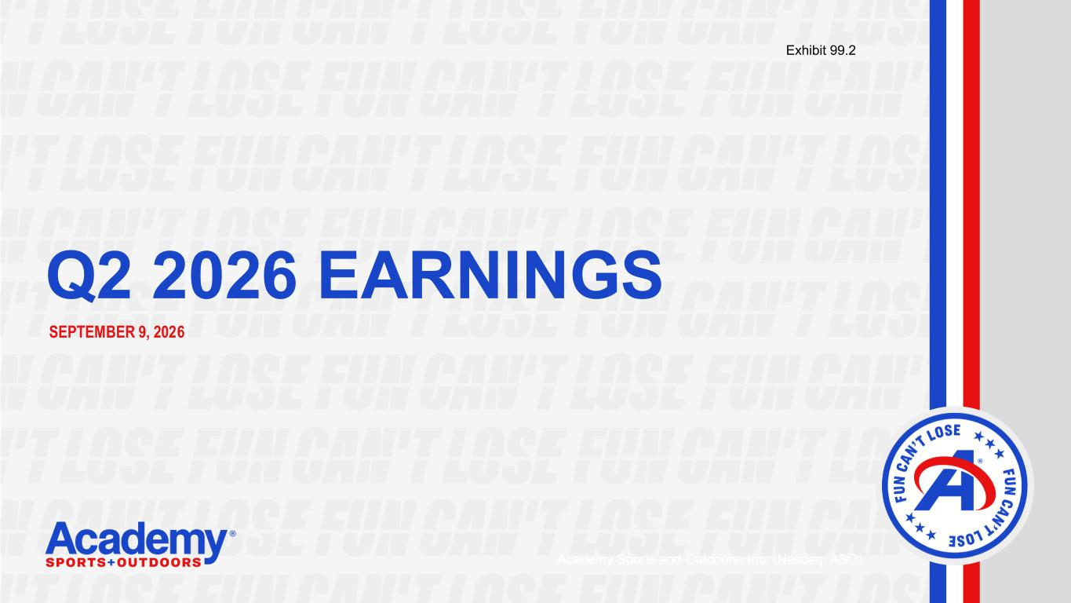
12
| Q2 2026 EARNINGS SEPTEMBER 9, 2026 Academy Sports and Outdoors, Inc. (Nasdaq: ASO) Exhibit 99.2

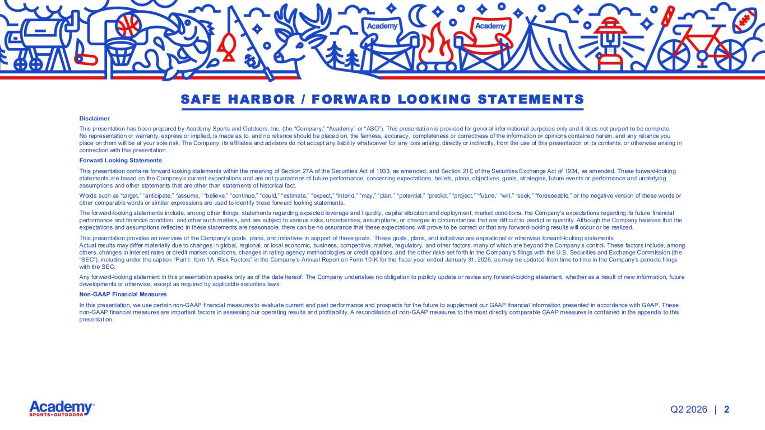
| 2Q2 2026 Disclaimer This presentation has been prepared by Academy Sports and Outdoors, Inc. (the “Company,” “Academy” or “ASO”). This presentation is provided for general informational purposes only and it does not purport to be complete. No representation or warranty, express or implied, is made as to, and no reliance should be placed on, the fairness, accuracy, completeness or correctness of the information or opinions contained herein, and any reliance you place on them will be at your sole risk. The Company, its affi liates and advisors do not accept any liability whatsoever for any loss arising, directly or indirectly, from the use of this presentation or its contents, or otherwise arising in connection with this presentation. Forward Looking Statements This presentation contains forward looking statements within the meaning of Section 27A of the Securities Act of 1933, as amended, and Section 21E of the Securities Exchange Act of 1934, as amended. These forward-looking statements are based on the Company’s current expectations and are not guarantees of future performance, concerning expectations, beliefs, plans, objectives, goals, strategies, future events or performance and underlying assumptions and other statements that are other than statements of historical fact. Words such as “target,” “anticipate,” “assume,” “believe,” “continue,” “could,” “estimate,” “expect,” “intend,” “may,” “plan, ” “potential,” “predict,” “project,” “future,” “will,” “seek,” “foreseeable,” or the negative version of these words or other comparable words or similar expressions are used to identify these forward looking statements. The forward-looking statements include, among other things, statements regarding expected leverage and liquidity, capital allocation and deployment, market conditions, the Company’s expectations regarding its future financial performance and financial condition, and other such matters, and are subject to various risks, uncertainties, assumptions, or changes in circumstances that are difficult to predict or quantify. Although the Company believes that the expectations and assumptions reflected in these statements are reasonable, there can be no assurance that these expectations will prove to be correct or that any forward-looking results will occur or be realized. This presentation provides an overview of the Company's goals, plans, and initiatives in support of those goals. These goals , plans, and initiatives are aspirational or otherwise forward-looking statements Actual results may differ materially due to changes in global, regional, or local economic, business, competitive, market, regulatory, and other factors, many of which are beyond the Company’s control. These factors include, among others, changes in interest rates or credit market conditions, changes in rating agency methodologies or credit opinions, and the other risks set forth in the Company’s filings with the U.S. Securities and Exchange Commission (the “SEC”), including under the caption “Part I. Item 1A. Risk Factors” in the Company's Annual Report on Form 10-K for the fiscal year ended January 31, 2026, as may be updated from time to time in the Company’s periodic filings with the SEC. Any forward-looking statement in this presentation speaks only as of the date hereof. The Company undertakes no obligation to publicly update or revise any forward-looking statement, whether as a result of new information, future developments or otherwise, except as required by applicable securities laws. Non-GAAP Financial Measures In this presentation, we use certain non-GAAP financial measures to evaluate current and past performance and prospects for the future to supplement our GAAP financial information presented in accordance with GAAP. These non-GAAP financial measures are important factors in assessing our operating results and profitability. A reconciliation of non-GAAP measures to the most directly comparable GAAP measures is contained in the appendix to this presentation. SAFE HARBOR / FORWARD LOOKING STATEMENTS

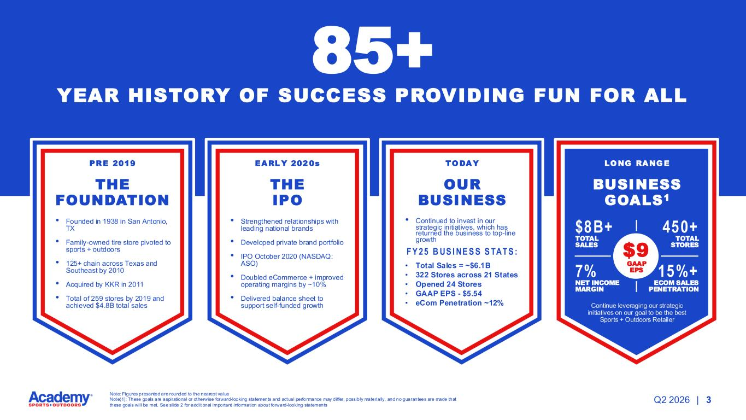
| 3Q2 2026 YEAR HISTORY OF SUCCESS PROVIDING FUN FOR ALL PRE 2019 THE FOUNDATION • Founded in 1938 in San Antonio, TX • Family-owned tire store pivoted to sports + outdoors • 125+ chain across Texas and Southeast by 2010 • Acquired by KKR in 2011 • Total of 259 stores by 2019 and achieved $4.8B total sales EARL Y 202 0s THE IPO • Strengthened relationships with leading national brands • Developed private brand portfolio • IPO October 2020 (NASDAQ: ASO) • Doubled eCommerce + improved operating margins by ~10% • Delivered balance sheet to support self-funded growth TODAY OUR BUSINESS • Continued to invest in our strategic initiatives, which has returned the business to top-line growth LONG RANGE BUSINESS GOALS1 Continue leveraging our strategic initiatives on our goal to be the best Sports + Outdoors Retailer F Y 25 B US I NE S S S TAT S : • Total Sales = ~$6.1B • 322 Stores across 21 States • Opened 24 Stores • GAAP EPS - $5.54 • eCom Penetration ~12% $8B+ TOTAL SALES 450+ TOTAL STORES 7% NET INCOME MARGIN 15%+ ECOM SALES PENETRATION 85+ $9 GAAP EPS Note: Figures presented are rounded to the nearest value Note(1): These goals are aspirational or otherwise forward-looking statements and actual performance may differ, possibly materially, and no guarantees are made that these goals will be met. See slide 2 for additional important information about forward-looking statements

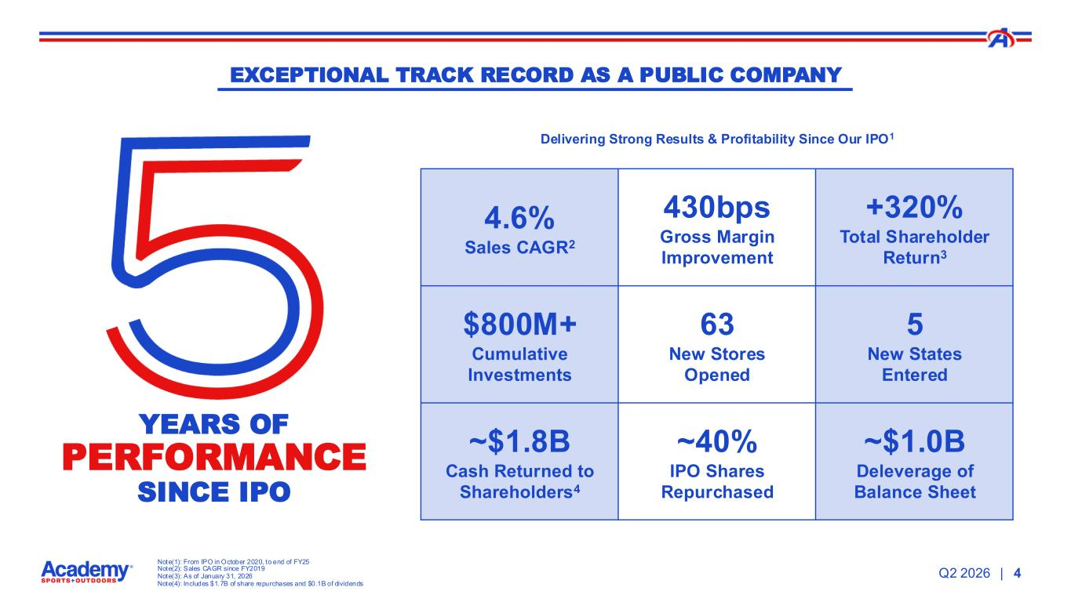
| Note(1): From IPO in October 2020, to end of FY25 Note(2): Sales CAGR since FY2019 Note(3): As of January 31, 2026 Note(4): Includes $1.7B of share repurchases and $0.1B of dividends Q2 2026 4 EXCEPTIONAL TRACK RECORD AS A PUBLIC COMPANY YEARS OF PERFORMANCE SINCE IPO Delivering Strong Results & Profitability Since Our IPO1 4.6% Sales CAGR2 430bps Gross Margin Improvement +320% Total Shareholder Return3 $800M+ Cumulative Investments 63 New Stores Opened 5 New States Entered ~$1.8B Cash Returned to Shareholders4 ~40% IPO Shares Repurchased ~$1.0B Deleverage of Balance Sheet

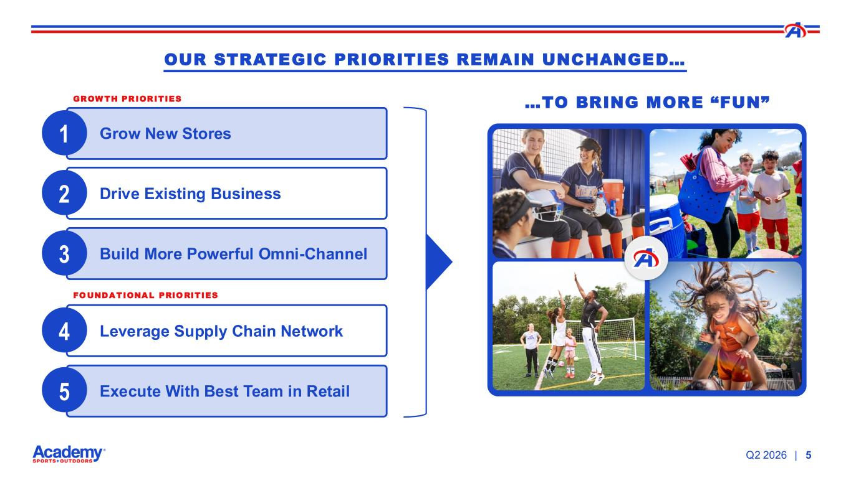
|Q2 2026 5 Grow New Stores Drive Existing Business Build More Powerful Omni-Channel Leverage Supply Chain Network Execute With Best Team in Retail 1 2 3 4 5 OUR STRATEGIC PRIORITIES REMAIN UNCHANGED… …TO BRING MORE “FUN”GROWTH PRIORITIES FOUNDATIONAL PRIORITIES

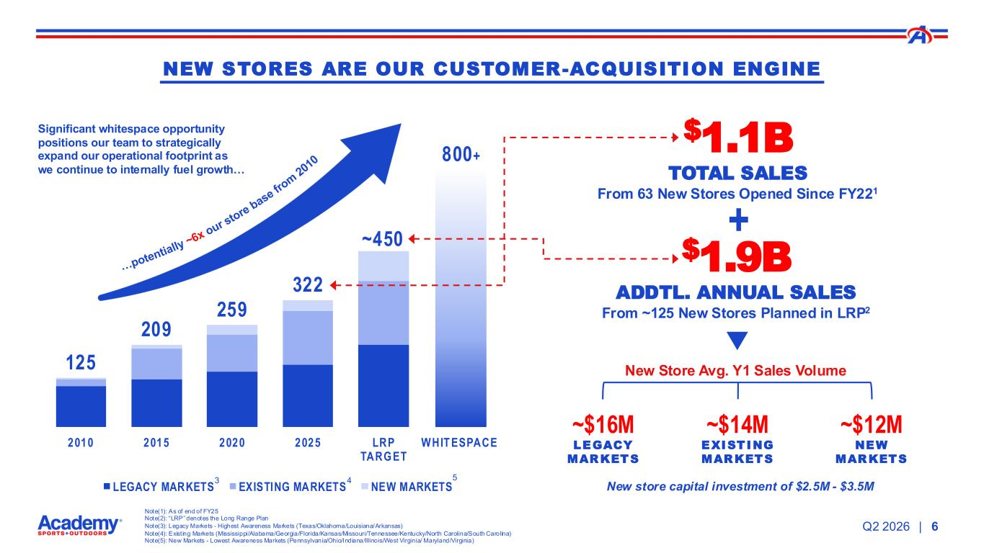
| 125 209 259 322 ~450 2010 2015 2020 2025 LRP TARGET WHIT ESPACE LEGACY MARKETS EXISTING MARKETS NEW MARKETS 5 800+ …potentially ~6x our store base fro m 2010 Q2 2026 6 $1.1B TOTAL SALES From 63 New Stores Opened Since FY221 Significant whitespace opportunity positions our team to strategically expand our operational footprint as we continue to internally fuel growth… Note(1): As of end of FY25 Note(2): “LRP” denotes the Long Range Plan Note(3): Legacy Markets - Highest Awareness Markets (Texas/Oklahoma/Louisiana/Arkansas) Note(4): Exist ing Markets (Mississippi/Alabama/Georgia/Florida/Kansas/Missouri/Tennessee/Kentucky/North Carolina/South Carolina) Note(5): New Markets - Lowest Awareness Markets (Pennsylvania/Ohio/Indiana/Illinois/West Virginia/ Maryland/Virginia) + $1.9B ADDTL. ANNUAL SALES From ~125 New Stores Planned in LRP2 New Store Avg. Y1 Sales Volume ~$16M LEGACY MARKETS ~$14M EXISTING MARKETS ~$12M NEW MARKETS NEW STORES ARE OUR CUSTOMER-ACQUISITION ENGINE New store capital investment of $2.5M - $3.5M 3 4

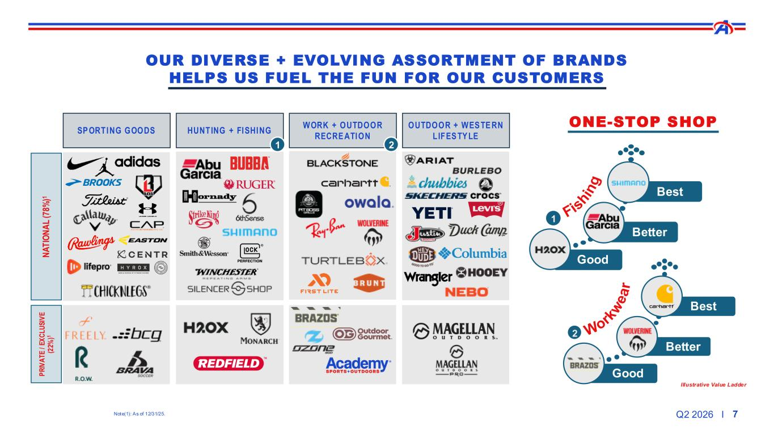
Q2 2026 I 7 OUR DIVERSE + EVOLVING ASSORTMENT OF BRANDS HELPS US FUEL THE FUN FOR OUR CUSTOMERS SP ORTING GOODS HUNTING + FISHING WORK + OUTDOOR RECRE ATION OUTDOOR + WES TE RN LIFES TY LE N A T IO N A L ( 78 % )1 1 2 P R IV A T E / E X C L U S IV E (2 2% )1 Illustrative Value Ladder Good Better Best Work w e a r 2 1 Good Better Best Fis h in g ONE-STOP SHOP Note(1): As of 12/31/25.

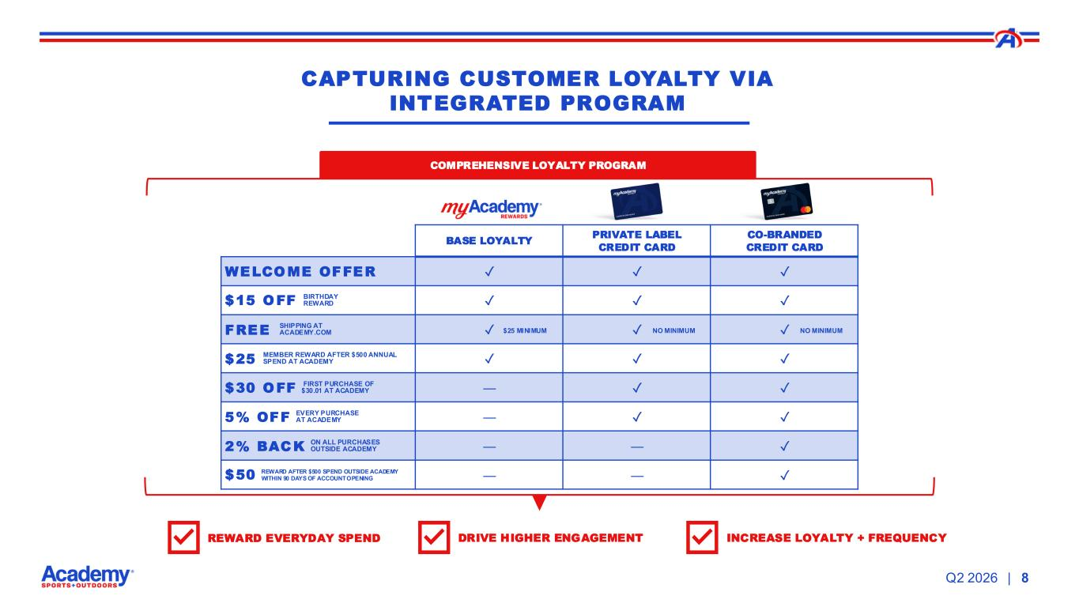
| BASE LOYALTY PRIVATE LABEL CREDIT CARD CO-BRANDED CREDIT CARD ✓ ✓ ✓ BIRTHDAY REWARD ✓ ✓ ✓ SHIPPING AT ACADEMY.COM ✓ ✓ ✓ MEMBER REWARD AFTER $500 ANNUAL SPEND AT ACADEMY ✓ ✓ ✓ FIRST PURCHASE OF $30.01 AT ACADEMY — ✓ ✓ EVERY PURCHASE AT ACADEMY — ✓ ✓ ON ALL PURCHASES OUTSIDE ACADEMY — — ✓ REWARD AFTER $500 SPEND OUTSIDE ACADEMY WITHIN 90 DAYS OF ACCOUNT OPENING — — ✓ Q2 2026 8 SIMPLIFY MY SHOP RESPECT MY TIME STRETCH MY DOLLAR FUEL THE FUN COMPREHENSIVE LOYALTY PROGRAM REWARD EVERYDAY SPEND DRIVE HIGHER ENGAGEMENT INCREASE LOYALTY + FREQUENCY CAPTURING CUSTOMER LOYALTY VIA INTEGRATED PROGRAM WELCOME OFFER $15 OFF FREE $25 MINIMUM NO MINIMUM NO MINIMUM $25 $30 OFF 5% OFF 2% BACK $50

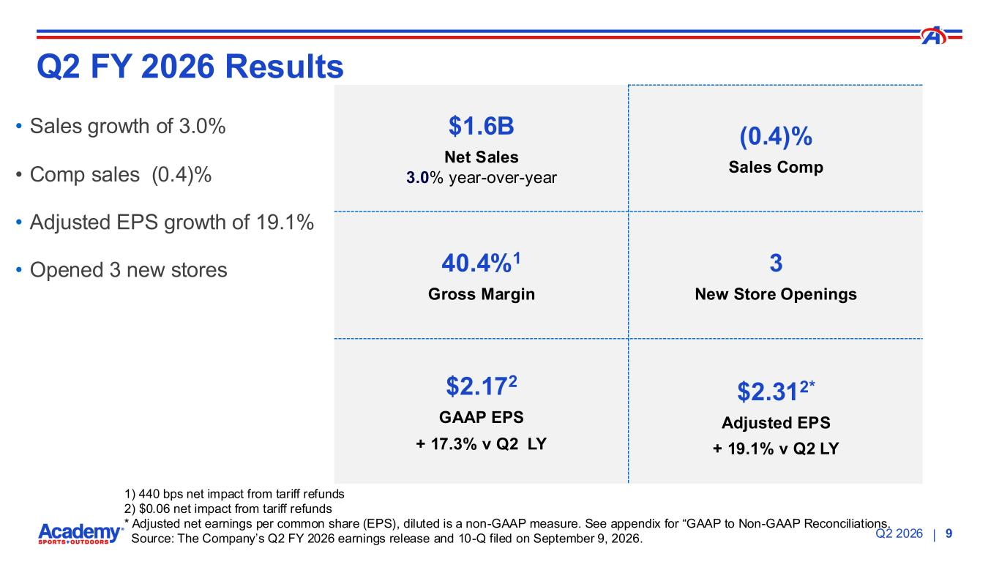
|Q2 2026 9 $1.6B Net Sales 3.0% year-over-year (0.4)% Sales Comp 40.4%1 Gross Margin 3 New Store Openings $2.172 GAAP EPS + 17.3% v Q2 LY $2.312* Adjusted EPS + 19.1% v Q2 LY Q2 FY 2026 Results • Sales growth of 3.0% • Comp sales (0.4)% • Adjusted EPS growth of 19.1% • Opened 3 new stores 1) 440 bps net impact from tariff refunds 2) $0.06 net impact from tariff refunds * Adjusted net earnings per common share (EPS), diluted is a non-GAAP measure. See appendix for “GAAP to Non-GAAP Reconciliations. Source: The Company’s Q2 FY 2026 earnings release and 10-Q filed on September 9, 2026.​

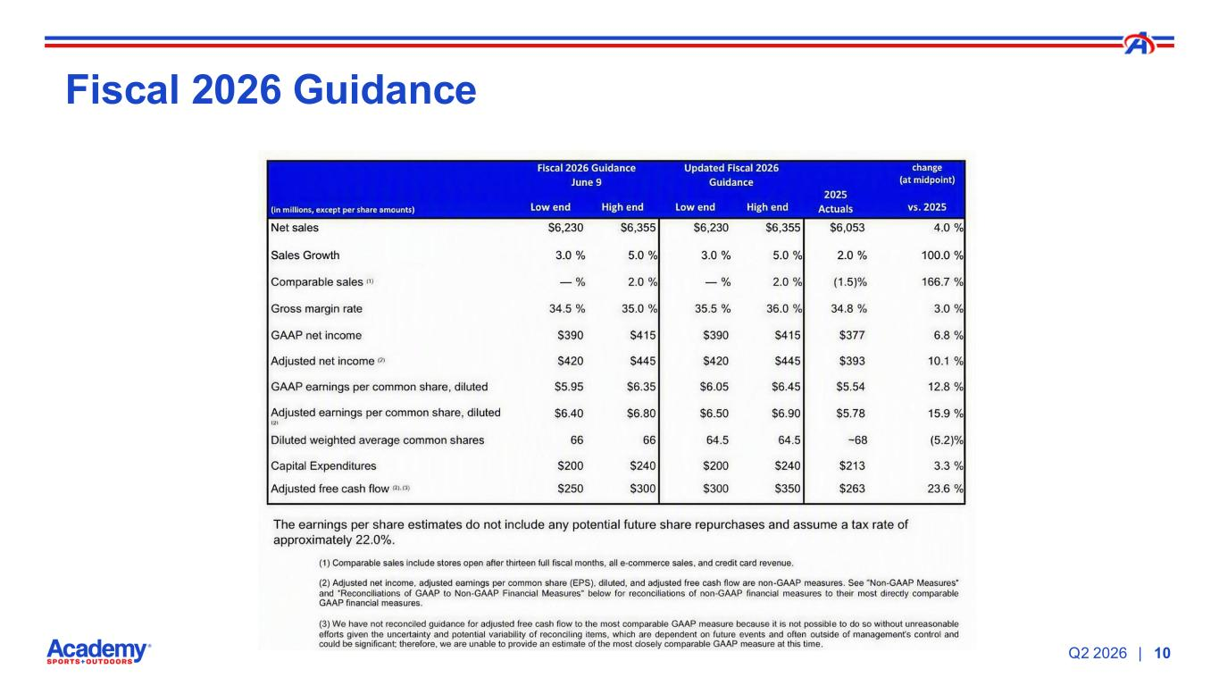
|Q2 2026 10 SIMPLIFY MY SHOP RESPECT MY TIME STRETCH MY DOLLAR FUEL THE FUN Fiscal 2026 Guidance

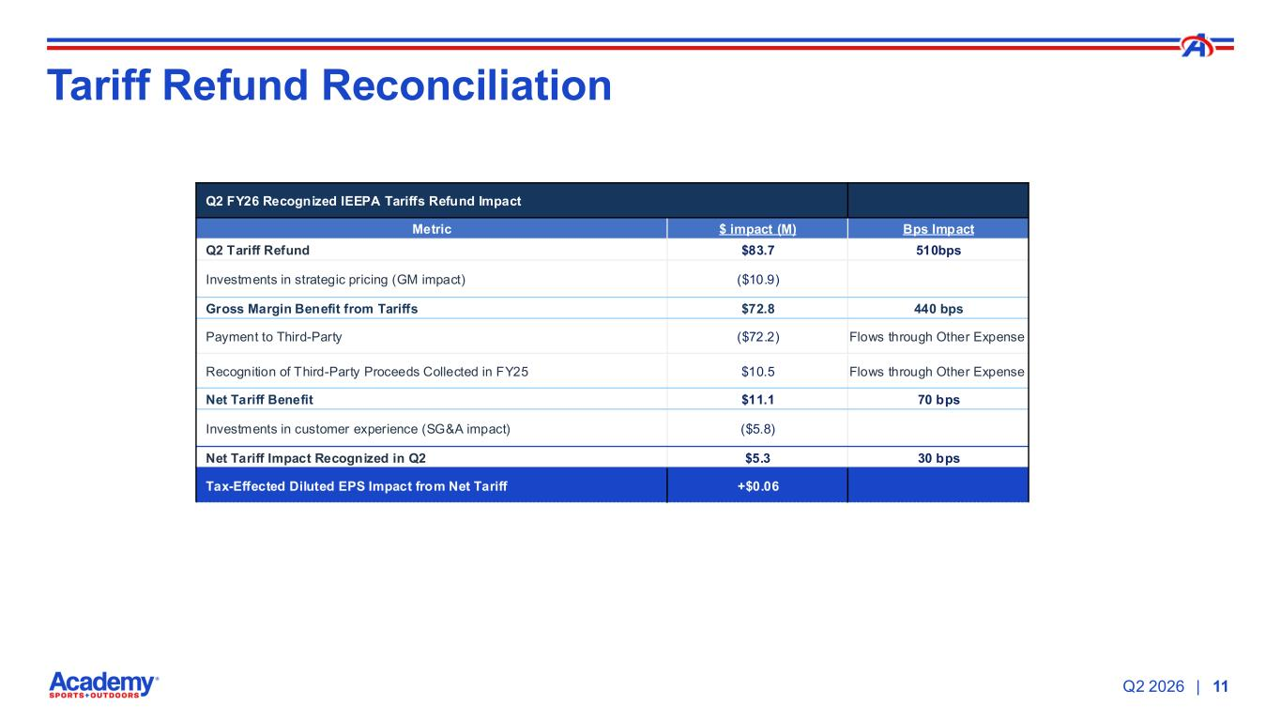
|Q2 2026 11 Tariff Refund Reconciliation Q2 FY26 Recognized IEEPA Tariffs Refund Impact Metric $ impact (M) Bps Impact Q2 Tariff Refund $83.7 510bps Investments in strategic pricing (GM impact) ($10.9) Gross Margin Benefit from Tariffs $72.8 440 bps Payment to Third-Party ($72.2) Flows through Other Expense Recognition of Third-Party Proceeds Collected in FY25 $10.5 Flows through Other Expense Net Tariff Benefit $11.1 70 bps Investments in customer experience (SG&A impact) ($5.8) Net Tariff Impact Recognized in Q2 $5.3 30 bps Tax-Effected Diluted EPS Impact from Net Tariff +$0.06

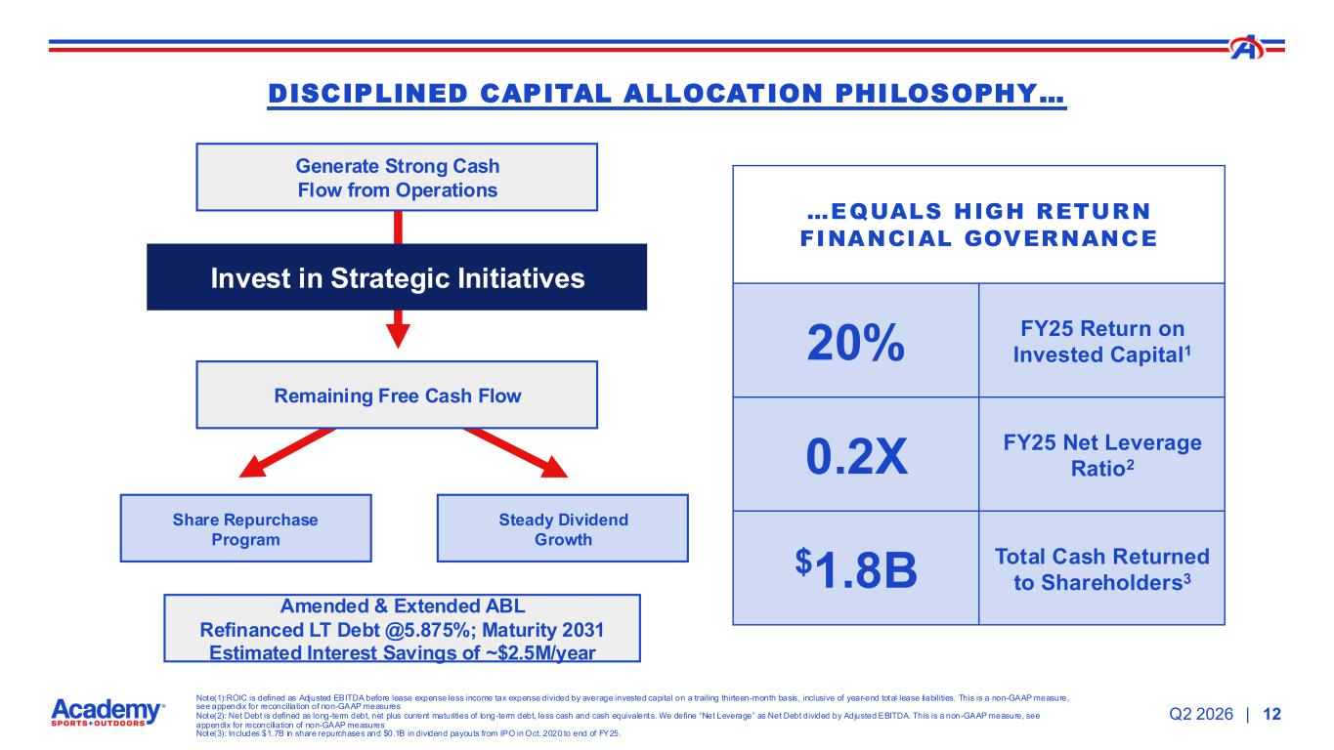
|Q2 2026 Note(1):ROIC is defined as Adjusted EBITDA before lease expense less income tax expense divided by average invested capital on a trailing thirteen-month basis, inclusive of year-end total lease liabilities. This is a non-GAAP measure, see appendix for reconciliation of non-GAAP measures Note(2): Net Debt is defined as long-term debt, net plus current maturities of long-term debt, less cash and cash equivalents. We define “Net Leverage” as Net Debt divided by Adjusted EBITDA. This is a non -GAAP measure, see appendix for reconciliation of non-GAAP measures Note(3): Includes $1.7B in share repurchases and $0.1B in dividend payouts from IPO in Oct. 2020 to end of FY25. 12 DISCIPLINED CAPITAL ALLOCATION PHILOSOPHY… …EQUALS HIGH RETURN FINANCIAL GOVERNANCE 20% FY25 Return on Invested Capital1 0.2X FY25 Net Leverage Ratio2 $1.8B Total Cash Returned to Shareholders3 Generate Strong Cash Flow from Operations Invest in Strategic Initiatives Steady Dividend Growth Remaining Free Cash Flow Share Repurchase Program Amended & Extended ABL Refinanced LT Debt @5.875%; Maturity 2031 Estimated Interest Savings of ~$2.5M/year

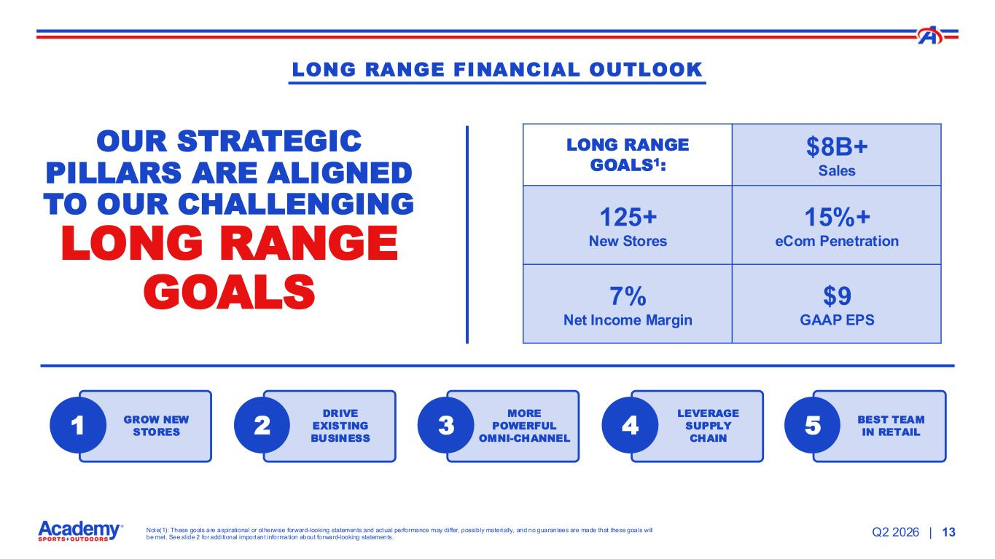
|Note(1): These goals are aspirational or otherwise forward-looking statements and actual performance may differ, possibly materially, and no guarantees are made that these goals will be met. See slide 2 for additional important information about forward-looking statements. Q2 2026 13 LONG RANGE FINANCIAL OUTLOOK OUR STRATEGIC PILLARS ARE ALIGNED TO OUR CHALLENGING LONG RANGE GOALS LONG RANGE GOALS1: $8B+ Sales 125+ New Stores 15%+ eCom Penetration 7% Net Income Margin $9 GAAP EPS GROW NEW STORES1 DRIVE EXISTING BUSINESS 2 MORE POWERFUL OMNI-CHANNEL 3 LEVERAGE SUPPLY CHAIN 4 BEST TEAM IN RETAIL5


Q2 2026 FINANCIALS This presentation has been downloaded and shared with Nasdaq. Please do not make any updates

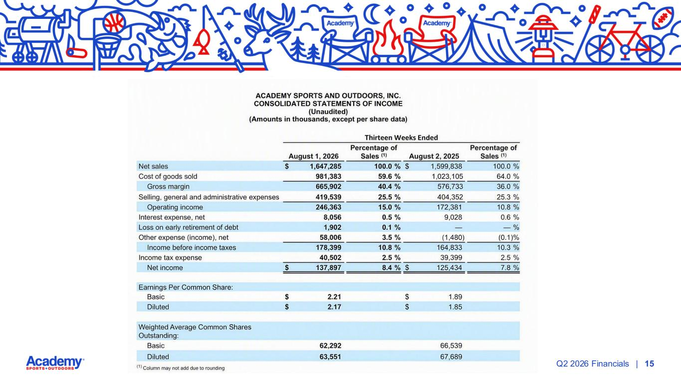
| 15Q2 2026 Financials

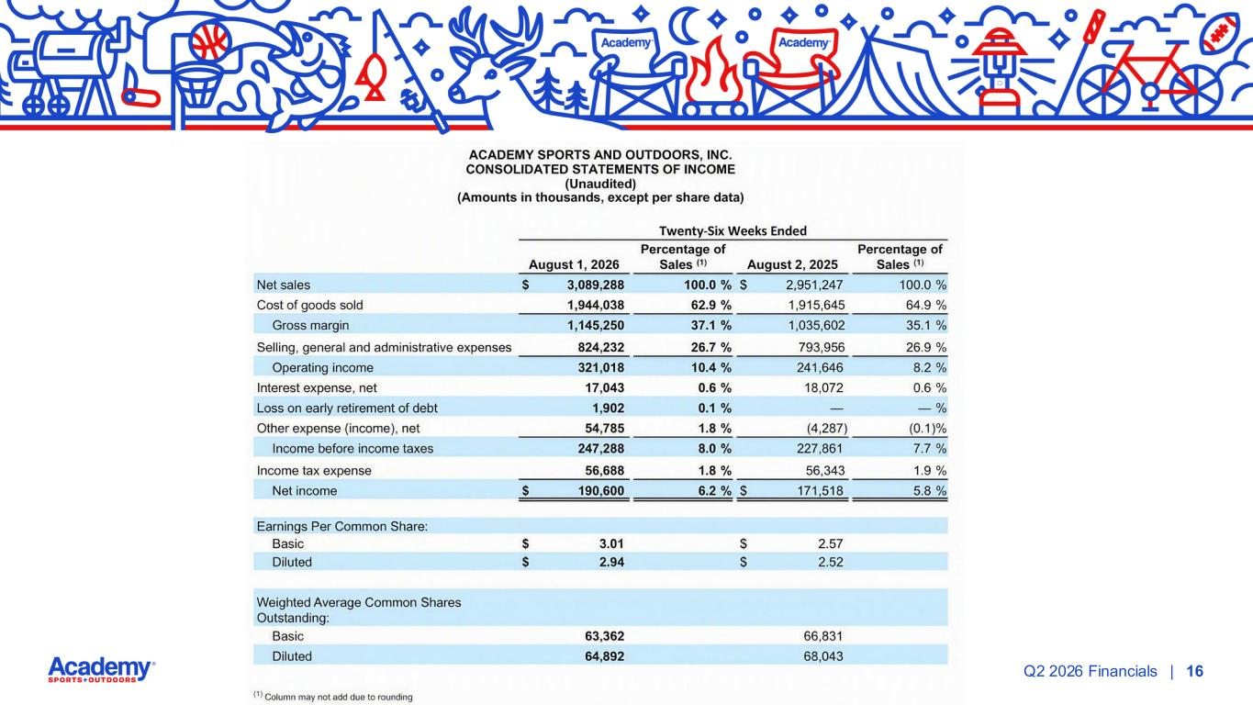
| 16Q2 2026 Financials

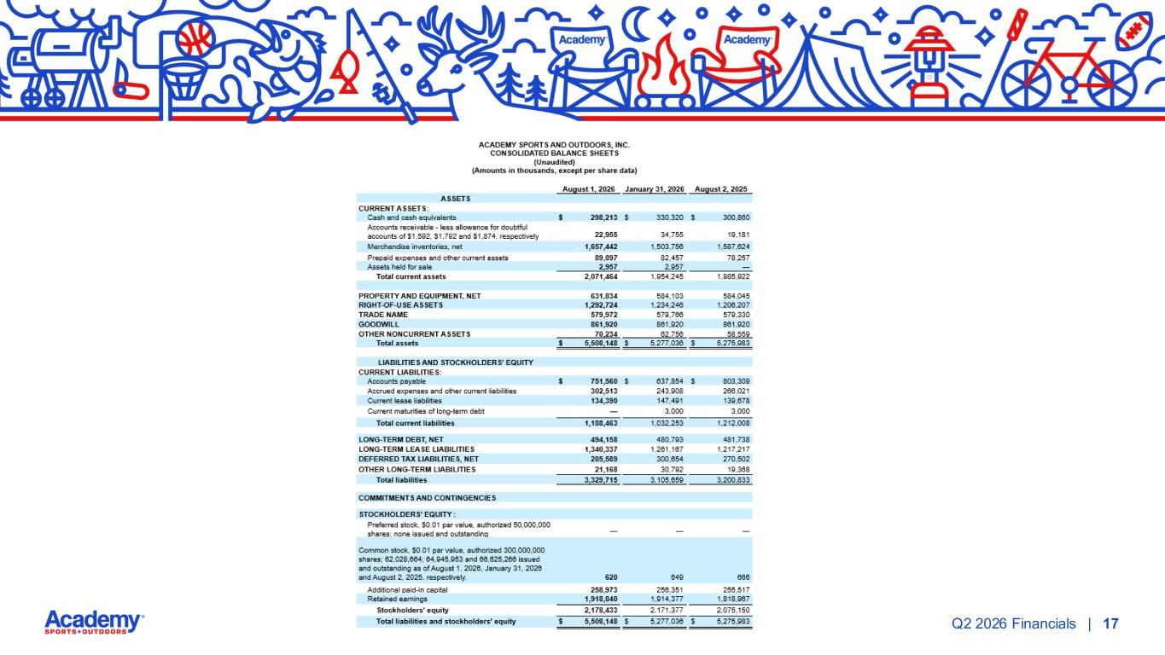
| 17Q2 2026 Financials

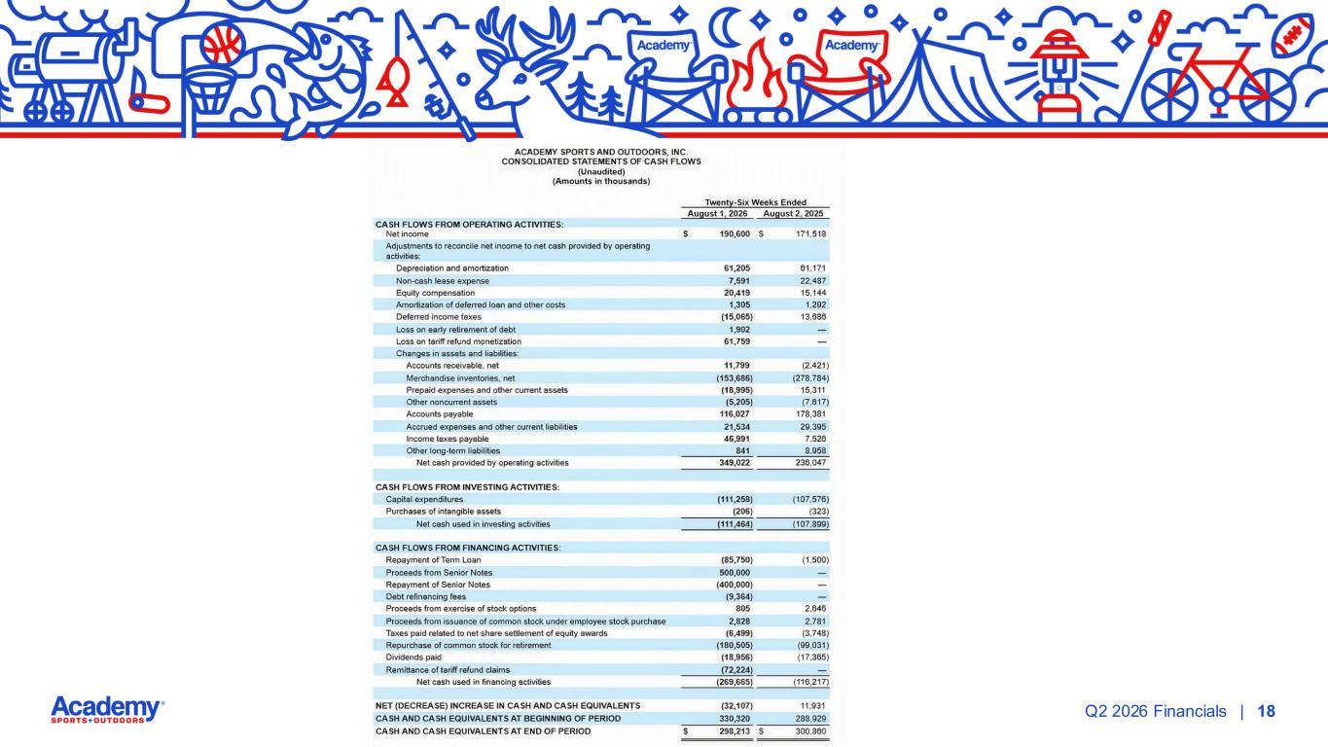
| 18Q2 2026 Financials

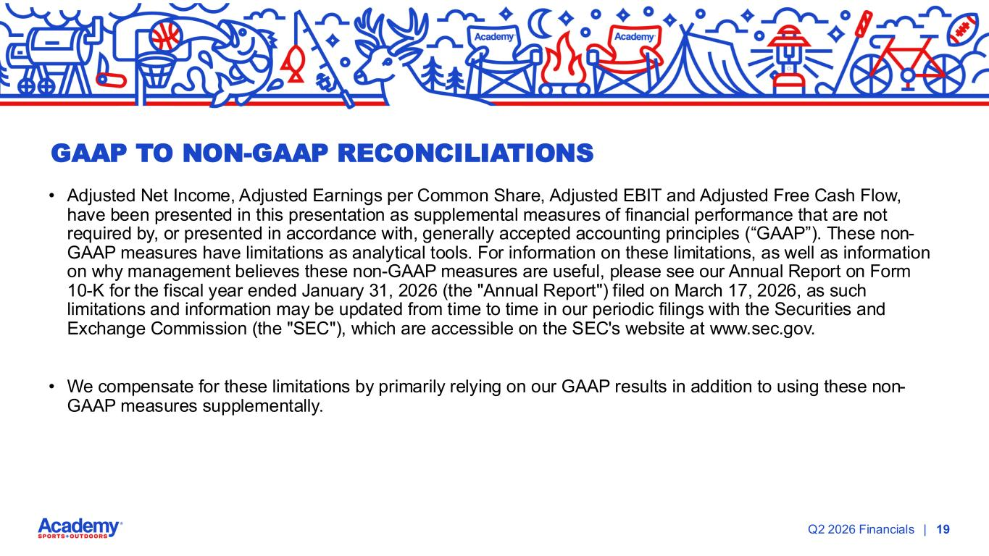
| 19Q2 2026 Financials • Adjusted Net Income, Adjusted Earnings per Common Share, Adjusted EBIT and Adjusted Free Cash Flow, have been presented in this presentation as supplemental measures of financial performance that are not required by, or presented in accordance with, generally accepted accounting principles (“GAAP”). These non- GAAP measures have limitations as analytical tools. For information on these limitations, as well as information on why management believes these non-GAAP measures are useful, please see our Annual Report on Form 10-K for the fiscal year ended January 31, 2026 (the "Annual Report") filed on March 17, 2026, as such limitations and information may be updated from time to time in our periodic filings with the Securities and Exchange Commission (the "SEC"), which are accessible on the SEC's website at www.sec.gov. • We compensate for these limitations by primarily relying on our GAAP results in addition to using these non- GAAP measures supplementally. GAAP TO NON-GAAP RECONCILIATIONS

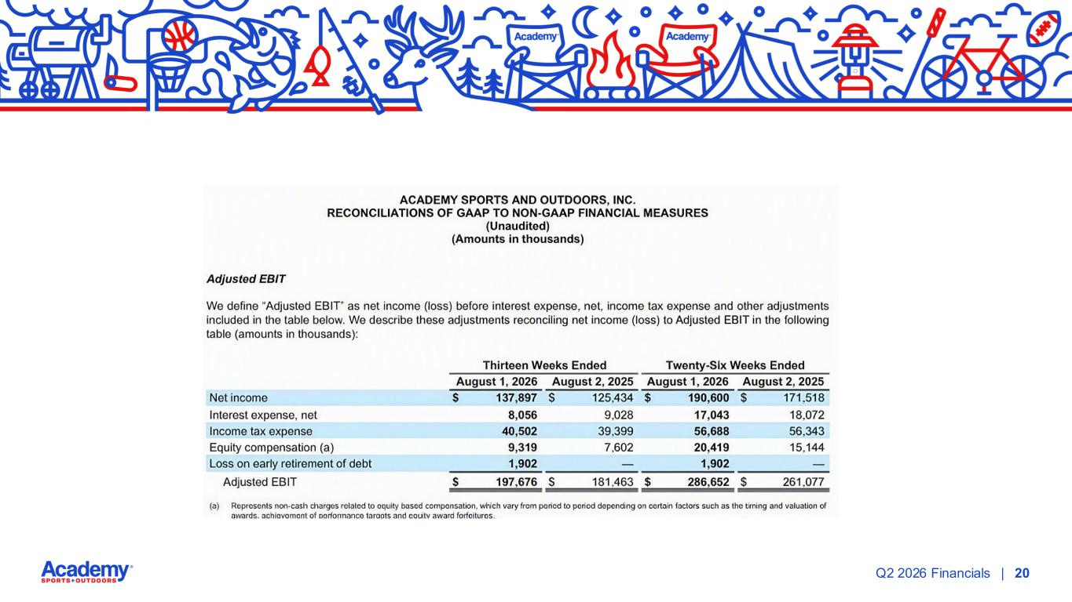
| 20Q2 2026 Financials

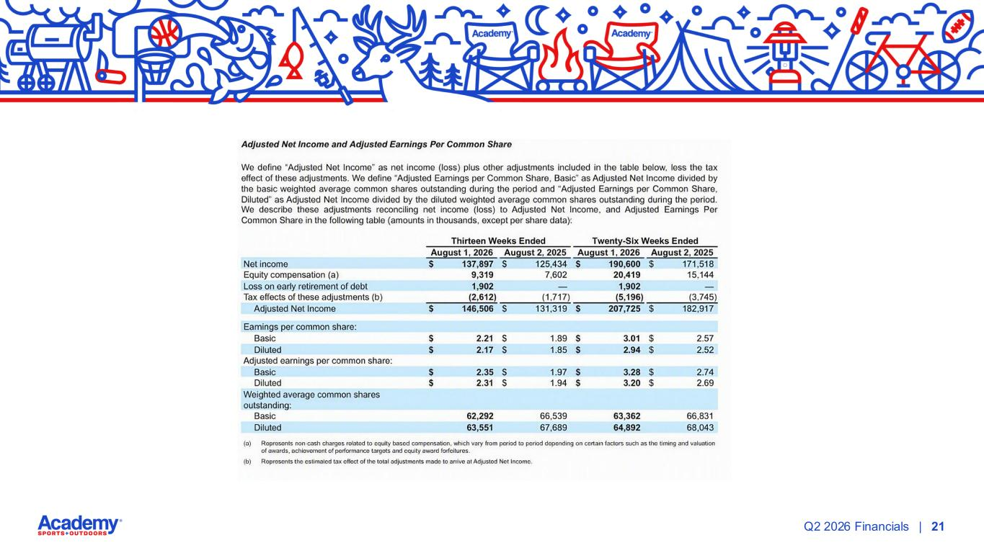
| 21Q2 2026 Financials

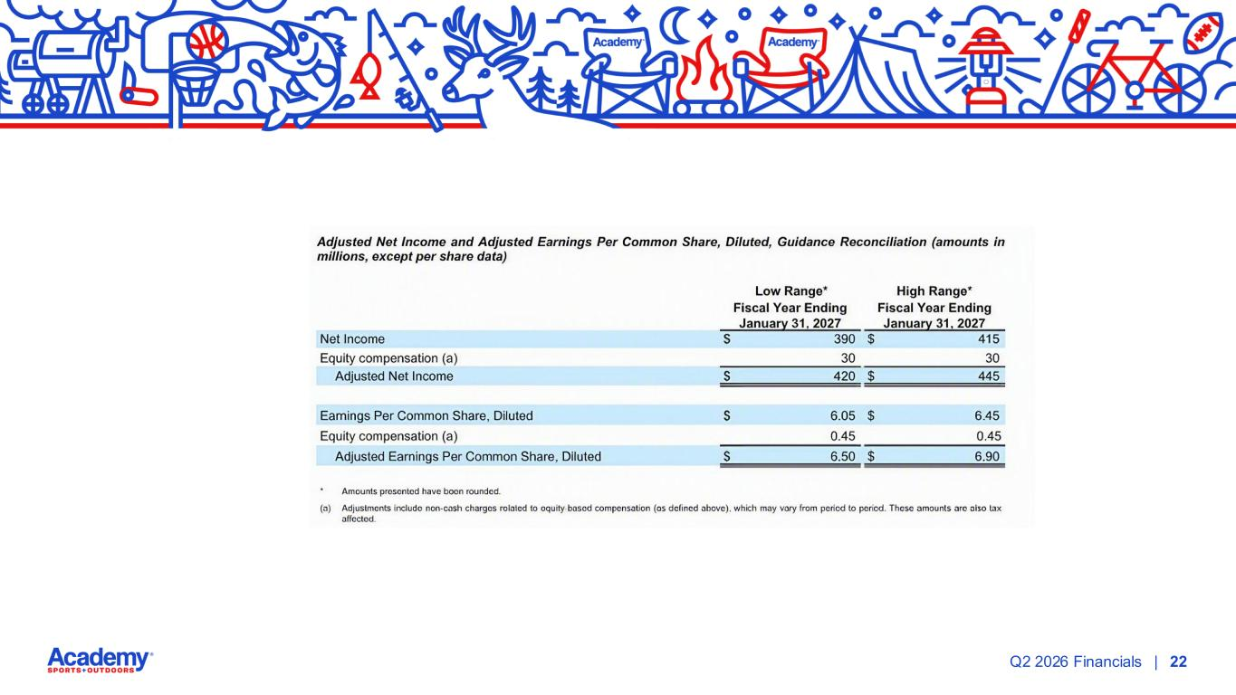
| 22Q2 2026 Financials

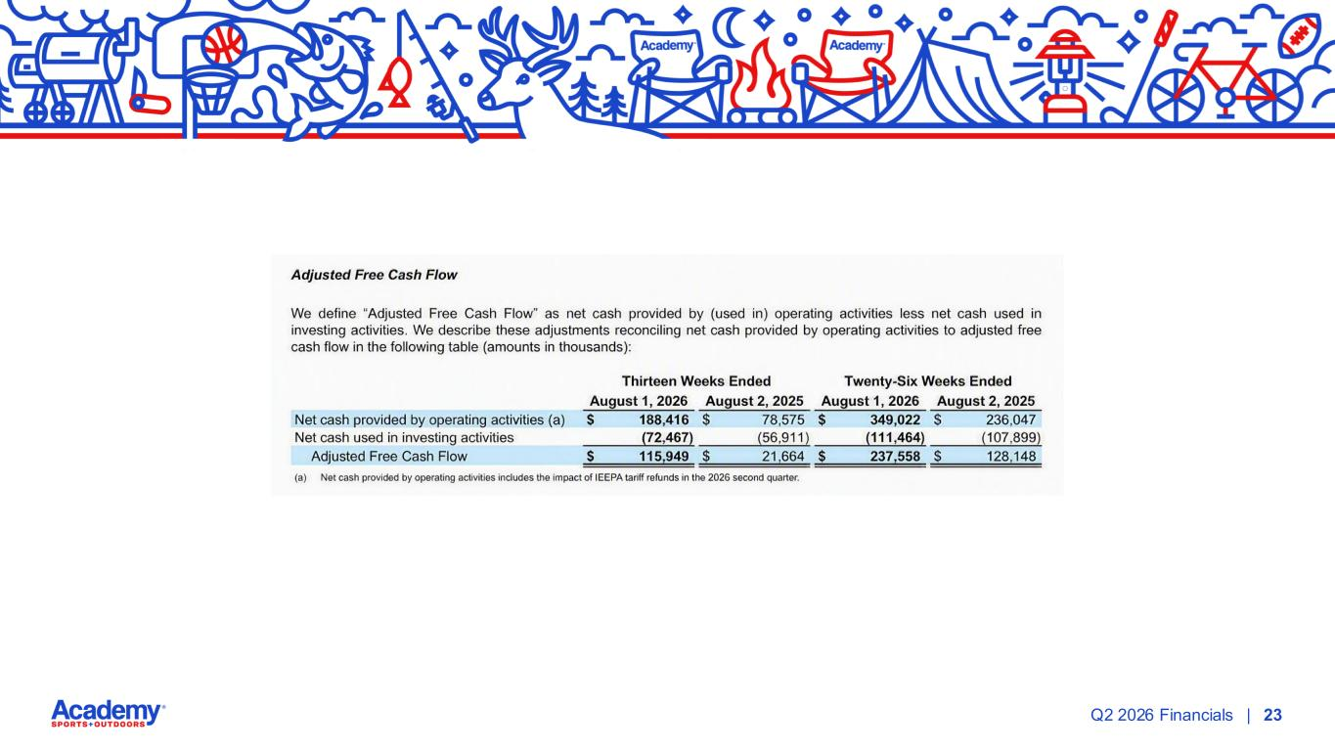
| 23Q2 2026 Financials

